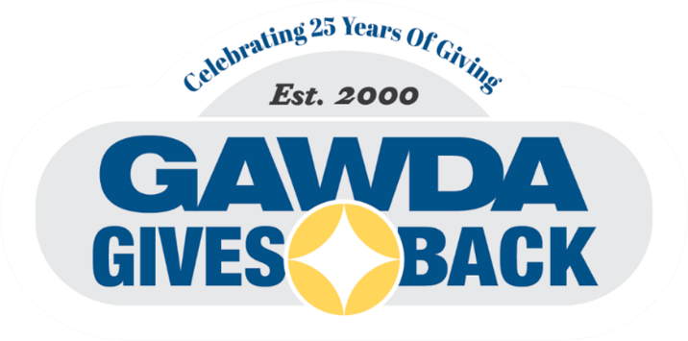
Fax to: (954) 367-7790
Mail to: GAWDA Headquarters
One Oakwood Blvd. Suite 195
Hollywood, FL 33020
Email to: bellenbogen@gawda.org
DONOR LEVEL SUGGESTIONS
CORPORATE DONOR
Diamond $10,000
Platinum $7,500
Gold $5,000
Silver $2,500
Bronze $1,000
Contributor $500
Supporter $250
Friend $100

INDIVIDUAL DONOR
Founders Club $2,500
Presidents Club $2,000
Members Club $1,000
Contributor $500
Supporter $250
Friend $100
Participant $50
GAWDA President Eric Wood and his wife Paula have selected Black Dagger of Florida as the 2025 GAWDA Gives Back Recipient. This is a non-profit organization that provides shooting, hunting, and fishing as well as other outdoor opportunities for wounded veterans.

Black Dagger Military Hunt Club of Florida serves wounded veterans from all eras without limitation to when and where they served. Black Dagger serves veterans recovering from and learning to adjust to life with spinal cord injuries, traumatic brain injuries, posttraumatic stress, loss of limbs, and loss of eye sight.

Thank you GAWDA members, for making a difference in the lives of others.

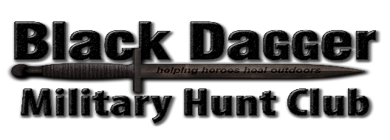

- YES! I want to make a contribution in the AMOUNT OF $ to 2025 GAWDA Gives Back Charity.
On Behalf of: (Please fill out official donation name for signage)
Donor Contact Name Company Name
Telephone Email

Payment Information
CHK (make check payable to GAWDA Gives Back) CC (Circle One) Visa MC Amex Discover
CARD NUMBER Exp. Date CVV
Cardholder Name
Signature
Billing Street City State Zip Code

